Sunday 20th September 2020
Matthew 20: 1-16
It’s not fair?.
Glo Tots | Sparkly Stars | Illuminate
(Pyjama church link to follow)

Resources:
- YouTube clip of bible reading
- Bible reading
- Craft/prayer activity
- YouTube link to songs
- Memory verse of the month (YouTube)

Main point: The last shall be first and the first shall be last – This story is about the generous vineyard owner who gave everyone the same even though some had worked harder and longer than others. To us that does not seem fair but the kingdom of God is like this. Everyone is welcome, Everyone can receive the same from God, the same amount of love, the same about of forgiveness, the same amount of the blessing whether old or young been a Christian for a little while or a Christian for years, whether you work for a church or not, whether you go to church every week and help out on every ministry or only go to chruch 1 every 6 months. Because it is not about us and what we do, we cannot earn God’s love. God’s love is for all not given out in different portions but for all – the same – God's reckless, turn it on it’s head type of love!
Introduction: Set up an unfair situation in your house. Maybe with sweets or biscuits or toys. Give one person more than others and I'm sure it won’t be long until someone says “It’s not fair”. How does it feel when something is not fair?

Bible Story:
https://youtu.be/uq0cJaPQpPY
Questions
- Why did the vineyard owner pay them the same? What does this tell us about God?

An action thing to help you to remember the story.

The last will be first
Jesus said, ‘Don’t just think about yourself.
Point to self.
I will share what I have with everyone.
Hold out arms.
Don’t be jealous!
Shake head.
When you come to my kingdom,
Make ‘crown’ with hands on head.
people who are first now
Hold up one finger in front.
will be last.
Point behind.
And people who are last now
Point behind.
will be first.’
Hold up one finger in front.
Pray – Draw a line down the middle of a large sheet of paper. Head one column ‘Us’, and the other ‘God’. Ask people to suggest answers to these two questions: What makes us angry? What makes God angry? Write the responses in the respective columns. (Alternatively, hand out newspapers and invite people to cut out stories of people being angry for themselves, and stories that they think make God angry, sticking these in the appropriate columns.) Discuss whether some stories could fit in both columns. End with a prayer that we may be appropriately angry about those things that make God angry, and that we may avoid anger that is selfish or self-centred.
Listen to this song and think about God’s love for us https://www.youtube.com/watch?v=Sc6SSHuZvQE
Craft activities:
- Story – George the generous griaffe https://www.youtube.com/watch?v=XCv44gU7mmU
- Make a list of ways you can be generous this week
- Make a stop go animation of this story using lego or palydoh etc... or a flicker book.
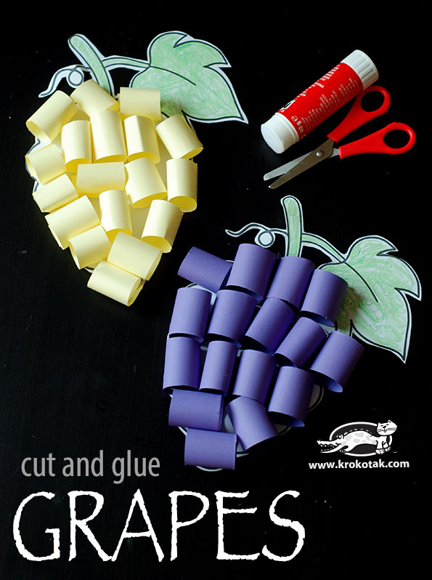 http://krokotak.com/2015/10/grapes-cut-and-glue/
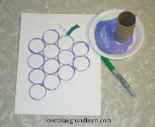
Choose a thing in the world which is not fair Eg. Famine, war, not water, toilet etc... and research chariteis that help with putting this wrong right.
Songs
Or God is a great Big God https://youtu.be/xIqEDBPlBVo
One thing reamins https://youtu.be/cKf6UZQEiA0

Monthly memory verse: https://youtu.be/t8yhQmgzbjw

Adapted from © ROOTS for Churches Ltd (www.rootsontheweb.com) 2002-2020.
Reproduced with permission.

