Sunday 12th July 2020
Matthew 13.1-9,18-23
Glo Tots | Sparkly Stars | Illuminate
(Pyjama church link to follow)

Resources:
- YouTube clip of bible reading
- Bible reading
- Craft/prayer activity
- YouTube link to songs
- Memory verse of the month (YouTube)
Main point: Jesus tells simple stories, called parables, to help people understand an important message.
Introduction: What is your favourite book? When Jesus was trying to explain things to people he tended to use stories to help to get his point across – why do you think he used stories to explain things? Stories are a really important part of our lives: they may be how we settle down ready to sleep; how we pass on memories; or the way we share our faith.
Jesus often uses parables – a story with a hidden meaning – to share a key message and this week we think about how and why he might have done this.

Lord Jesus, as we gather today,
may we have eyes to see
and ears to hear
what you are saying to us.
Make us ready to learn
from your stories.
Amen.
Bible Story:
https://www.biblegateway.com/passage/?search=Matthew+13&version=GNT Bible story Matthew 13

You tube https://www.youtube.com/watch?v=IZEO_Ls2ERs

Questions:
Who is the farmer?
What is the seed?
Who do you think the different types of soil are?
Which is the best soil to be and why?
How can we be the good soil?

Pray – What’s up prayer?
W – Wow God – what do you want to say wow to God for?
T – Thank you
S – Sorry
P – please

Craft activities:
- Can you make the 4 differet soils outside? Can you use it to maybe make a stop go animation?
- Can you plant some seeds? Think about how you need to look after seed so it can grow?
- Can you make a collage of natural materials all about seeds growing?
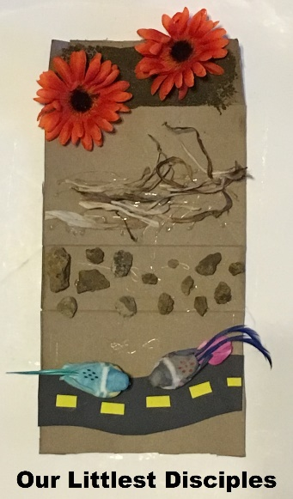

Mini book https://members.10minutesofqualitytime.com/product/the-parable-of-the-farmer-and-the-seeds-mini-book/

Songs
Joy https://www.youtube.com/watch?v=xtqAMwWik2k to 4:29 min
Faith https://www.youtube.com/watch?v=JUG4AXD8RgI
Monthly memory verse: https://www.youtube.com/watch?v=Jd35-M-xLX4&list=PL3RJJ8ZMuQa9RjPyC0KC0Ixxk1G05OaO8&index=3
Adapted from © ROOTS for Churches Ltd (www.rootsontheweb.com) 2002-2020.
Reproduced with permission.

