Sunday 4th July 2021
God is enough – Mark 6: 1-13
Main point: God tells the disciples to take little and to trust that he has it sorted. As they were made vulnerable and trusted in God their faith grew stronger.
Introduction: scavenger hunt for things you may take with you on a trip.

Bible Story:
Bible:

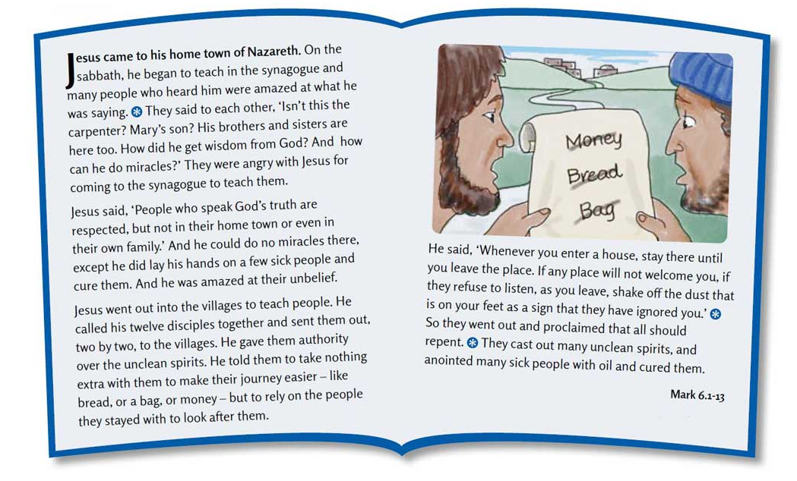
What 1 thing would you choose if you were going on a journey?

How do you think the disciples felt not having stuff with them? Why did Jesus tell them to not take much?

Do you think their relationship with God was stronger?

Do we find it easy to trust God for everything? Do you trust that God will find the right job for your mummy or daddy? Do you trust God that he will provide you with good friends at school? Do you trust God that he has good plans for your future – the job you will do? The subjects you study? Trust God when you are sad that he is there with you?
Young children:
Prepare a bag with the following objects and invite the children to
pull them out as you tell the story: map, money, stick, sandals, cross.
One day, Jesus gathered his disciples together
and told them he was sending them on a journey. (map)
But Jesus told them to take nothing with them (money)
apart from a walking stick (stick)
and the sandals they were wearing (sandals)
because Jesus wanted them to rely completely on God. (cross)
As they went on their journey,
they were to tell people about Jesus,
and make people better.
Prayer –
WhaTS uP Prayers Worship, thank you, sorry, please
Lord’s prayer: cheeky pandas https://youtu.be/CfUfQDKw50A (8:50 - 9:29)
Craft activities:
- make a maze and guide someone blinded folded through it – disciples had to trust God where to go.
- Do a reverse relay race. You need to take a full bag and take it in turns to empty it. Who can empty it in the quickest time?
- parachute prayers http://flamecreativekids.blogspot.com/search/label/trust
- draw round your foot, decorate it and put it somewhere to remind you that Jesus says Go but not by ourselves because he is with us.

Songs
every step https://youtu.be/nZBhKp5_HwE
Ask seek knock? https://youtu.be/Wlkb7SyjqII
Monthly memory verse: See website https://www.stnics.org.uk/children-families
Adapted from © ROOTS for Churches Ltd 2002-2020. Reproduced with permission. www.rootsontheweb.com

